|  |
| --- |
| **American International University- Bangladesh** |
| OOP1 Final Term Project Report FOOD ORDERING SYSTEM  Project Submitted By:  1.RAHIKUL ZANNAT - ID-17-33962-1  2.NAFIZ AHMED NAHID - ID-17-34682-2  3. NAIMUL ISLAM - ID-17-35067-2  NAN |

**Group No : C08**

**Course : Object Oriented Programming -1**

**Section : C**

**Date :19/8/2019**

**FOOD ORDERING SYSTEM**

**Introduction:**

We are doing this project because by using this system employee and customer can easily contact each other. Also customer can order their food from their account and employees always aware about the situation and manage that easily . The GUI of this management system is comparatively easier to implement.

**User Category:**

There are two types of Users here. They are:

* Employee
* Customer

**Feature List:**

In this project the “Employee” has the following features:

* Employees will only be able to see their information and edit profile
* They have primary ID
* They have their names
* They have their different salary
* They have their designation

In this project the “Customer” has the following features:

* They have primary ID
* They have their own name
* They have their phone no.
* They can update their personal info
* They can order food
* They Can register new id

**GUI Description:**

By this GUI employees and customers can log into the system to see their personal info . Here button “Show” shows the password ,button “Login” helps to log in , button “Exit” helps to go out of system ,by button “Registration” customer can add their info .

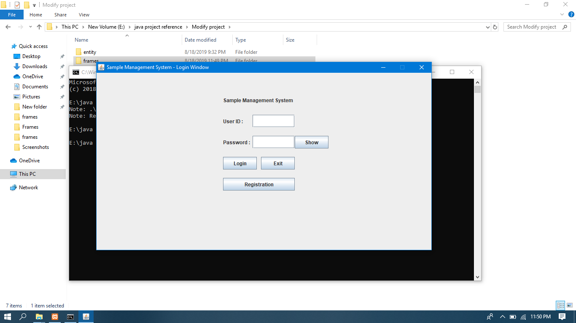

From this Login-window Employee or Customer can login to their homepage portal. As they are the user here and they can do their acts according to their accessibility.

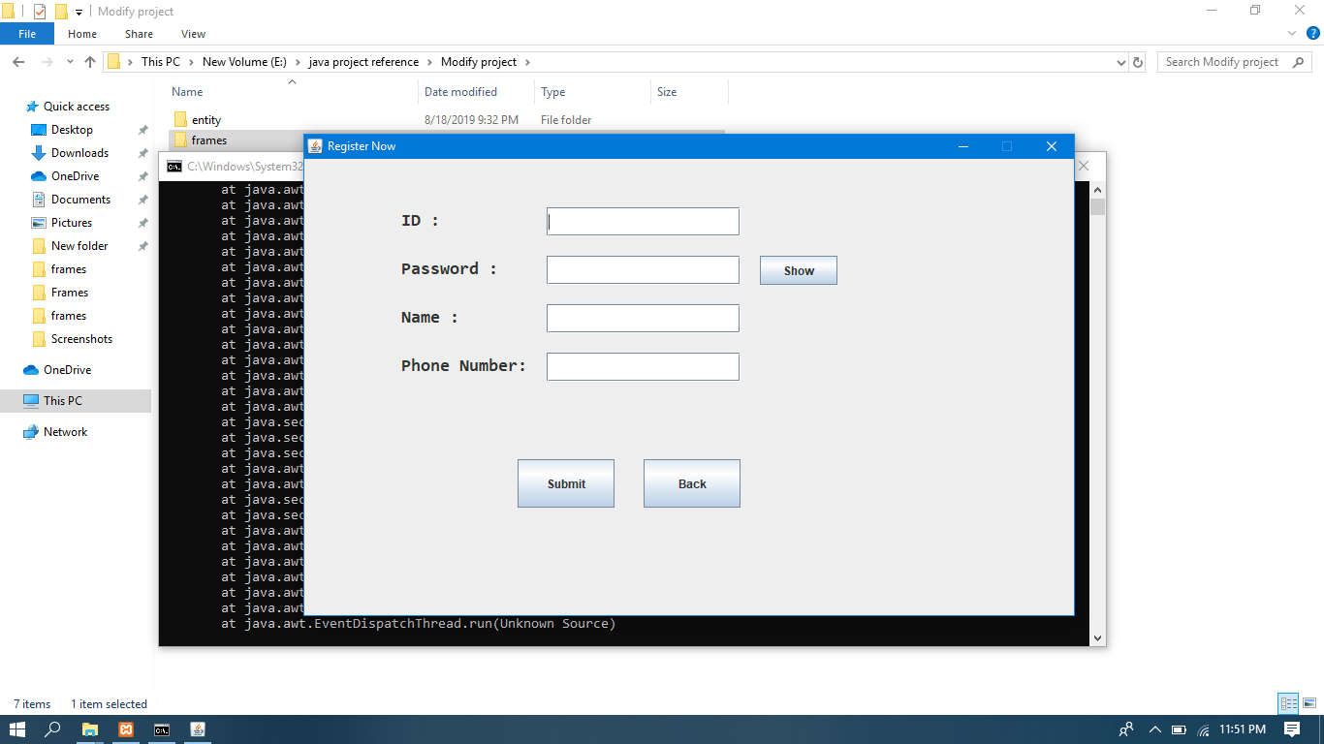

Here in this “Registration” GUI customer can add their ID,password ,name ,phone number.

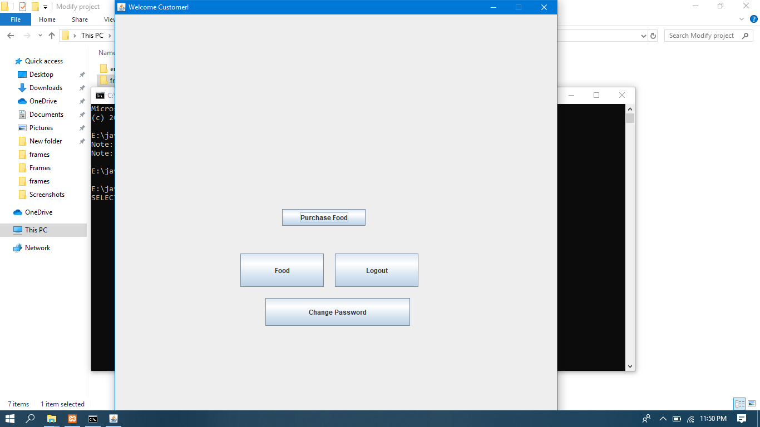

Here in this GUI customers can look the info’s about food ,and purchase food and by clicking in “Change password” button customer can change his account password .

**Database Table Description:**

screen shot of the database table structures:

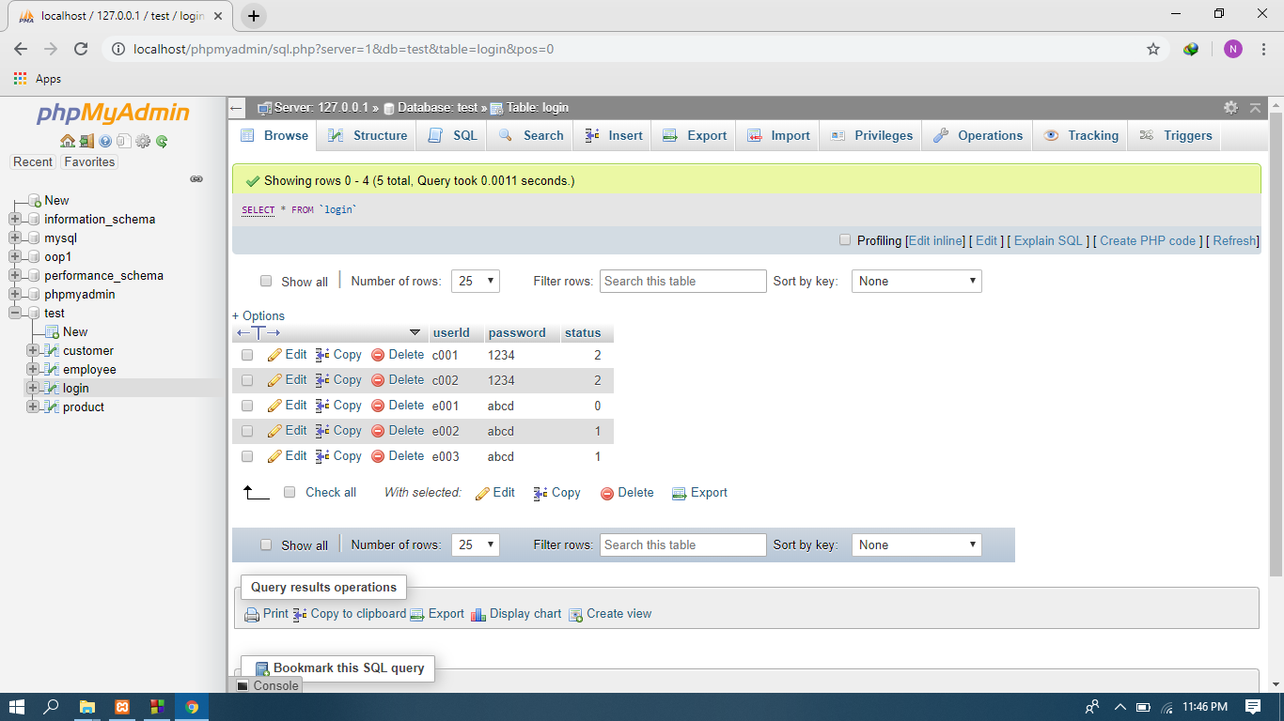

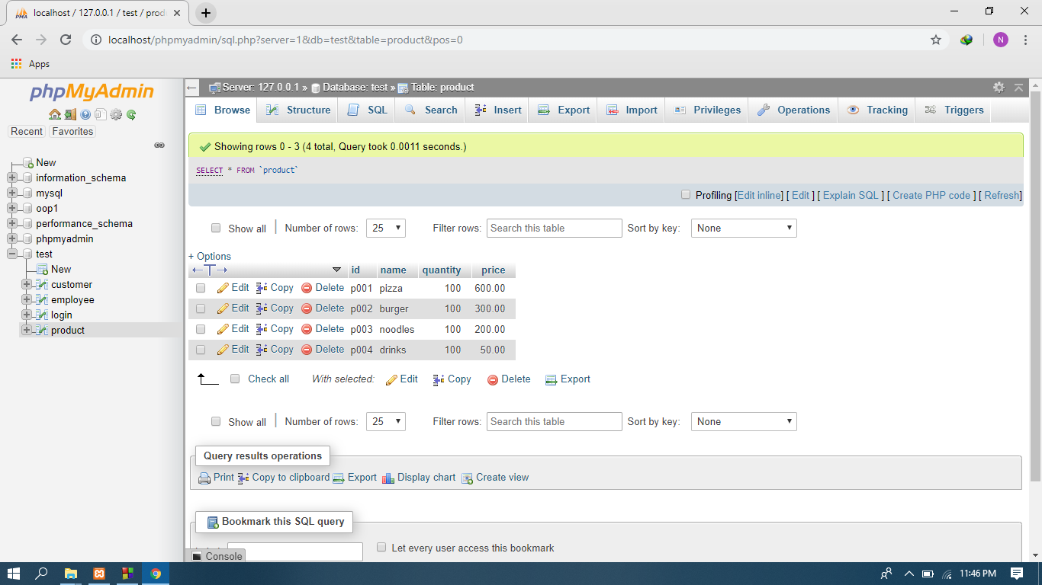

**Class Diagram:**

**purchase manage**

**FOOD ORDERING SYSTEM**

**Tools Used:**

To develop this project we have used the following:

* Notepad ++
* xampp
* phpMyAdmin

**OOP and Java Concepts Used:**

* Concept 1: Get Set method
* Concept 2: Inheritance
* Concept 3: Interface
* Concept 4: Package
* Concept 5: GUI
* Concept 6: Database

**Impact of “FOOD ORDERING SYSTEM” :**

By using this food ordering system customer can easily order food and employee can easily handle the order. In this system customers can order different kind of foods from their existing account or register a new one for ordering food and employees serve food to them as per their order and always updated about the situation . Besides this system is very simple and user friendly to use for any Food-ordering-system which is very much beneficial for this business .Data and information is very easy to get and Adding, inserting, updating and collecting any data and information is very simple in this system.

By using this food ordering system employee or customer can easily contact

**Limitations and Possible Future Improvements:**

The limitations are there are no information about the foods, there is no option for online delivery and the improvement that could be done is that more information about food and employee can be added ,online features can be added and many more other improvements required by the owner and customers.